Project Design Phase-II
Data Flow Diagram & User Stories

Date | 30 September 2026
Team ID | SWTID-2026-7743
Project Name | AI FAQ Assistant API
Maximum Marks | 4 Marks

Data Flow Diagrams:
A Data Flow Diagram (DFD) is a traditional visual representation of the information flows within a system. A neat and clear DFD can depict the right amount of the system requirement graphically. It shows how data enters and leaves the system, what changes the information, and where data is stored.
DFD Level-1 for the AI FAQ Assistant API:
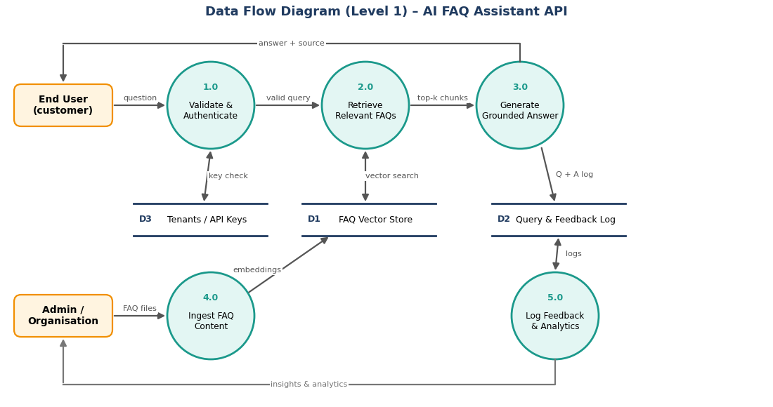
External entities are the End User (asks questions) and the Admin / Organisation (uploads FAQs). Process 1.0 validates the API key against D3 and the request; 2.0 searches the FAQ vector store D1; 3.0 generates a grounded answer and logs it in D2; 4.0 ingests uploaded FAQ files into D1; 5.0 turns logs and feedback into analytics for the admin.

User Stories
Use the below template to list all the user stories for the product.
User Type | Functional Requirement (Epic) | User Story Number | User Story / Task | Acceptance criteria | Priority | Release
Customer (Web user) | Ask a Question | USN-1 | As a customer, I can type a question in the chat widget and get an answer taken from the company's FAQs. | Answer is shown within 3 seconds and matches the FAQ content | High | Sprint-2
 |  | USN-2 | As a customer, I can see which FAQ the answer came from. | Source FAQ title / ID is shown with the answer | High | Sprint-2
 |  | USN-3 | As a customer, I get a clear message when the assistant is not sure, so I am not given a wrong answer. | Low-confidence question shows "I don't know" with a contact option | High | Sprint-2
Customer (Mobile user) | Ask a Question | USN-4 | As a mobile user, I can ask questions through the company's mobile app that calls the API. | Same JSON answer as web; works with a valid API key | Medium | Sprint-2
Customer (Web / Mobile) | Multilingual Support | USN-5 | As a customer, I can ask in Tamil or Hindi and get the answer in the same language. | Language detected automatically; reply in the same language | Medium | Sprint-3
 | Feedback | USN-6 | As a customer, I can rate an answer with thumbs up / down. | Feedback is saved and visible in analytics | Medium | Sprint-3
Customer Care Executive | Escalation | USN-7 | As a customer care executive, I can view questions the assistant could not answer, so I can reply manually. | Unanswered questions listed with date and question text | High | Sprint-3
 |  | USN-8 | As a customer care executive, I can add the missing answer as a new FAQ. | New FAQ is indexed and used in later answers | Medium | Sprint-3
Administrator | Registration & Login | USN-9 | As an administrator, I can register my organisation and receive an API key. | Account created; API key displayed once | High | Sprint-1
 |  | USN-10 | As an administrator, I can log in with email and password. | Valid login opens the dashboard; invalid login is rejected | High | Sprint-1
 | FAQ Management | USN-11 | As an administrator, I can upload FAQ files (CSV / JSON / PDF). | Success message shows the number of FAQs indexed | High | Sprint-1
 |  | USN-12 | As an administrator, I can view, edit and delete FAQs. | Changes appear in answers within a minute | High | Sprint-3
 | Analytics & API Control | USN-13 | As an administrator, I can see top and unanswered questions, and revoke or regenerate my API key. | Dashboard charts load; revoked key stops working immediately | Medium | Sprint-3

